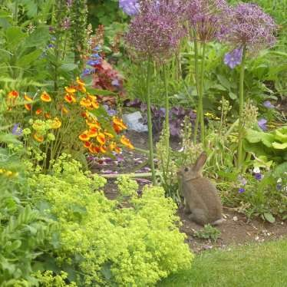

The Newsletter for Middleton on the Wolds

Issue No 29

AUGUST

2021

NEXT COPY DATE
14th August

Please send in your contributions to middletonflyer@yahoo.com by the end of the copy day. If I don’t acknowledge them please get in touch to make sure they have arrived.
The library vehicle is still running and Hazel has asked me to put the times in The Messenger for your information.
One of my photos on the front again, I’m afraid. This time it is of a recent visitor to our garden. I love rabbits and they are always a welcome sight but I just hope he gets his supper somewhere else!
Mike is on holiday at the time of compiling The Messenger so there are no words of wisdom from him this month.
Lyn
4 The Paddocks 219500

ADVERTISING COSTS for the Messenger
Rates Month Year

Whole Page £25 £150

1/2 Page £15 £100

1/3 Page £10 £60
Full colour - Print run 500 copies
Contact: Tina 01377 217242, middletonflyer@yahoo.com
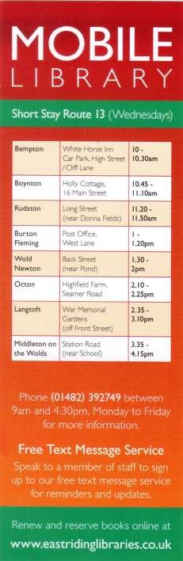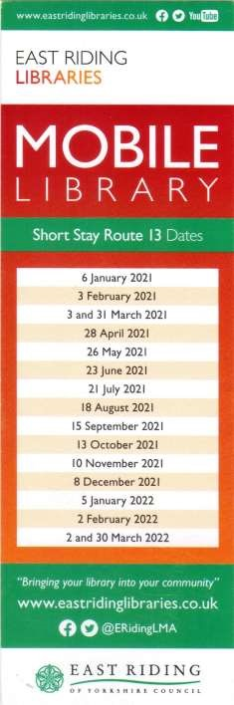

correspondence
Dear all,
It has just been confirmed that Ancestry.com/library edition will be available for home use for our customers, until 31 December 2021
Please pass the good news on to anyone who you think might enjoy using this - and I hope you all have fun accessing the information.
Many thanks
Sarah
Sarah Hutchinson
Librarian – Bridlington library, Stamford Bridge library, Hedon
Centre & Withernsea Centre
Tel: (01262) 672917 Direct dial (759) 203 Mobile: 07885741453
Web: www.eastriding.gov.uk
Twitter: www.twitter.com/East_Riding
Facebook: www.facebook.com/eastridingcouncil
As the Recreation Club Chairman I would like to give a big public thank you to Andrew Naylor whose quick action prevented possible serious injury to anyone as he noticed that one of the picnic benches had been vandalised and the sharp end of several screws were left exposed .
Apparently one gentleman in the village had already fallen to the floor as a result of attempting to sit on the damaged seat .
I have to say that his repairs are first class and couldn't be better .The bench is strong as it ever was and it's good we have residents in the village who do things that benefit our community.
Well done !
Dave Newlove

Notice about the Olympic Gala Day Event
8th August 2021

CANCELLED
Sadly, all the grants we applied for and the requests for sponsorship have been refused.
Therefore, the Gala day event including the 4.5k Race has had to be cancelled.
Thank you to the all who offered help with use of their resources and equipment at no charge, and the 22 villagers who volunteered to help with the Gala day, it is very much appreciated.
In particular, thanks to Cindy Perry, Lesley Kelly and Liz Harros for their guidance and assistance in this matter.

PRESCRIPTION SERVICE UPDATE
After August I will no longer be able to have the responsibility of collecting the repeat prescription sheets from The Post Office due to work commitments.
The prescriptions will still be collected from The Medical centre surgery and brought to The Post Office on a Thursday
Louise

QUIZ PAGE
1 What number is written XC in Roman numerals? 2 Whose is the third gospel in the New Testament?
- Which gang in West Side Story shares its name with a fish?
- A ruby wedding anniversary celebrated how many years of marriage?
- What country is the setting for Disney"s Beauty and the Beast?
- What river does New York's George Washington cross?
- Name the Chess Piece?
What desert did David Livingstone cross in 1849 the Atacama, Gobi or
8
Kalahari?
- The song Take a Chance on Me is from what stage musical?
- Lake Como is the deepest lake in which European country?
Quiz set by Rowland Wooldridge
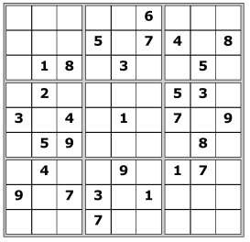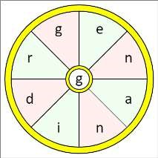SUDOKU
All answers on
page 18

SEASONAL WORD WHEEL

Try and find the full word, then make
as many words of any length as you
can from these letters. You can only
use each letter once, and each word
must include the letter

G

St Andrew’S church

Services for August

Sunday 1st August. Morning Prayers at 10.30.a.m. C/W.

Sunday 8th.August. Joint Worship at 10.30.a.m Rev`d Jane Anderson

Sunday 15th. August. Holy Communion at 10.30.a.m.Rev`d Canon Kate Goulder.

Sunday 22nd. August. Holy Communion at 10.30.a.m.Rev`d Ruth Newton.

Sunday 29th. August. Benefice Holy Communion at 10.00.a.m.Venue TBC.

We very much hope we can resume hymn singing at these services.

All are welcome.

The wolds METHODIST CHURCH bainton

Services for August
Sunday 1st 10.30am | Service at the Wolds Methodist Church,
 | Deacon Keith Gough
Sunday 8th 10.30am | United Service at St Andrews Church Middleton
Sunday 15th 10.30am | Service at the Wolds Methodist Church,
Sunday 22nd 10.30am | Service at the Wolds Methodist Church,
 | Mr Hector Robinson
Sunday 29th 10.30am | Service at the Wolds Methodist Church,
 | Rev Colin Barrett, Holy Communion

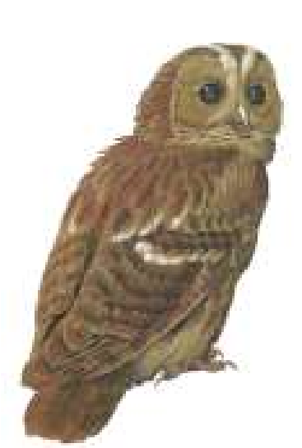
Local Birds & wildlife

The Owls Are Not What They Seem….. Sorry, that will make no sense at all if you did not watch Twin Peaks – come to think of it, it didn’t make much sense in the TV series either. But I digress: Pat had an unexpected visitor at the end of June.
“I went to bed about 10.30 last night and hadn’t been there long when I was disturbed by strange noises going on outside. I peeked out of the windows and it was still light so not burglars. I checked Barbara and Terry’s drive and nothing there either so got back in bed. However the strange noises continued. The flat
roof I thought. I looked out of the window again just in time to see a large owl land on the roof of our car. It sat there until a black cat ran across our driveway then it took flight and landed on Tina and Lynn’s chimney pot. So relieved it wasn’t anything sinister but so delighted to have an owl on the premises – a tawny by its colouring and size! P.S I think it came back as the noises started again. On the TV aerial I think.”
You would think that a car roof would feel a bit slippery and unsafe – I hope it didn’t scratch the paintwork! Many years ago in Leicester Ian had just dropped me off at home and suddenly felt he was being watched. He turned around and there was a barn owl just sitting in the road and staring fixedly at him. Never saw one anywhere in the neighbourhood again. Another weird sighting we had was in Norfolk just after dawn, when a barn owl with a small rodent in it’s beak landed on a post very near to us, and in defiance of all the documentaries showing owls swallowing prey whole, proceeded to tear it up bit by bit and eat the lot. Perhaps it had been doing this for its chicks, and fancied eating the same recipe itself?
Our mystery bird may have been identified; Eileen has since seen a young jackdaw on the same feeder, and it still had some brown on it, but was more recognisable. Jackdaws can get quite tame, I found a quote in the Birds Britannica:
“In Scalby near Scarborough there was a cottage where we used to buy
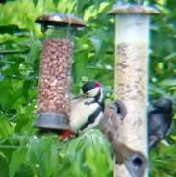
fishing permits for a stretch of the beck. The bloke there had a tame jackdaw and when you knocked on the door it would hop up to your feet and I swear it would say ‘Door Jack, Jack door.’ It caused us great mirth and the three of us who went fishing would always buy permits one at a time with the other two hiding around the corner.”
Last month I was worried by the lack of baby birds. I still haven’t any around the garden, but Barry and Joanna have been luckier – and got photos:
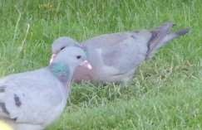
“We have been seeing lots of baby birds coming to the feeders including the woodpecker family many times a day. Our regular stock dove has been coming a lot, then last night it came with what appeared to be a well grown youngster. This is the first time we have ever had two in the garden at once.”
I enjoyed watching house martins
hurtling around at a friend’s house where they are nesting in the village (and there were tree sparrows on her feeders; I think I will go and camp in her garden) but still very few swallow sightings.
Ian was enjoying a bit of wildlife watching from the comfort of the sitting room yesterday:
“Mrs Pheasant turned up this morning, less common than a few weeks ago, but not a rare sighting. She pecked at the seed heads on the grass (No Mow May) for a while and then came and begged at the patio door. Iolo Williams on Springwatch says not to feed bread to the birds because it is like chewing gum to their digestions, but this was homemade and I know what is in it. I cut off a crust and threw it out. She pecked contentedly and – I thought – finished it off.
Move on two hours and Mrs has gone and a new visitor has arrived
(pictured). It’s a vole – not a mouse but I’m not sure which type. It got bolder and bolder, choosing various routes from the bushes at the side onto the patio and through the long grass. I let it play and after about half an hour I realised what the cause was when (after I had taken the card out of the camera) a slice of bread came past attached to a small vole half it’s size and vanished into the bushes. It’s interesting to think that something 5 or 6 cm long spotted or smelt a bit of bread 4 or 5 metres away and was prepared to risk so much exposure to capture such a prize.
I am flattered that my baking is so well regarded!”
Please send me any photos, comments, stories and sightings to lavenderbarbara97@gmail.com or text 0777 192 7868. I look forward to hearing from you!
Barbara

LOCAL HISTORY

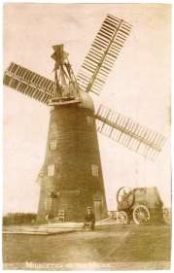
MILLS AND MILLERS

At the time of the Domesday Survey in 1087 the existence of mills in early village settlements was recorded but as these were water driven they would not have featured in the dry wolds landscape. In Mrs T Smith’s essay written for the Women’s Institute in the 1950s she recalled that in her childhood years in the 1880s and 90s there were three grinding mills in the village; two driven by wind and one by steam, the latter situated in the field behind Mrs Jenkinson’s house with William Storey as the miller. The 1855 ordnance survey map shows two mills, one situated near the parish boundary on the North Dalton Road in an area designated as a chalk pit which is now used for grazing: this is described as “ the old post mill, corn.” The other, a tower mill, was located near the Goodmanham Road on the
footpath known as “Mill Trod” and simply called A tower mill
“ windmill”. A photograph exists of the Middleton
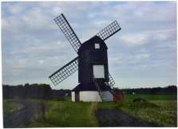
tower mill with a male figure in the foreground which is thought to be this particular structure but no photo is known to exist of the post mill so the one used in this article shows a surviving example at Ivinghoe in Buckinghamshire.

A post mill was the earliest type of windmill and it could be turned round to face the wind by pivoting on a bearing on top of the main post. These posts were massive uprights which were held in position by two or three crosstrees. As they required constant attention post mills
An example of a post mill were eventually replaced by Smock or
Tower mills and the design of these
reduced the proportion of the structure that had to be turned to face the wind, their sails being mounted on rotating cups. Changes in milling practice however led to the rapid decline of traditional windmills from the late nineteenth century.

It is not known when the mills in Middleton vanished from the scene and it would have been interesting if, as in some villages, the tower mill had been left in some form so that a tasteful redeployment could have been made at a later date. The last person listed in connection with milling was in the directory for 1901 when Arthur Dooks was described as “miller and assistant overseer”. Later directories show him as an “ agricultural seed merchant” A lasting reference to the trade was made however with the naming of the street of former council houses built after the second world war as “Millfield Garth”.

MILLERS

A directory for 1822 lists Robert Roantree as a corn miller and the following censuses make reference to persons engaged in the trade:-

Census

1841 James Webster Age 27 South Street

1851 James Roantree 37
Wilsh Crowe 23 Corn miller and landed proprietor Robert Hillerby 34 Corn Miller

1861 John Hill 35 Master Miller, North End
Wilsh Crowe 34 West End Farmer of 60 acres and miller

1871 John Hill 46 North Dalton Road, Master Miller
George Beals 31 Front Street, Master Miller

1881 Joseph Imeson 68 Retired Miller, North Dalton

1891 William Storey Miller (New Primitive Methodist Chapel)

In more recent times the sight of a windmill restored to carry out its original function as with that of a steam engine moving proudly through the countryside tends to evoke a feeling of nostalgia in people.for a lost world.

Geoff Wisher

Parish council

Recreation Ground Play Equipment Update
Work is expected to have commenced (by the time this newsletter has been delivered) on the play area on the 19th July and is expected to last for 3-4 weeks. The commencement date was unfortunately delayed due to bad weather having affected the timescale of the contractors' previous jobs.
We would like to take the opportunity to thank Soanes Poultry for sponsorship of the cost of the portable toilet for the contractors.
Cllr Tina Walker

Middleton book group
July Meeting

Yet another opportunity to meet in a sunny garden and we were pleased to welcome Jean, a new member, to the group.

Everyone had read “To Sir with Love” by E R Braithwaite, an autobiographical classic set shortly after World War II. He was born in British Guiana, served as an RAF pilot and obtained a masters degree from Cambridge but then found that no one wanted to employ a black engineer. He was advised to try teaching and the book tells his struggle to get the respect of a class of teenagers just about to leave school and how he helped them become ready for their working lives.

We all enjoyed it and also discussed the differences between the book and the film which was set ten years or so later. One member thought it depressing that the world hadn’t moved on far enough with regard to prejudice.

Not many had read the second book, “One Last Child” by Anni Taylor, but those that did enjoyed it. A very different genre from To Sir with Love, this is a novel set in The Blue Mountains of Australia and is about a group of 3 year old children who were abducted during a nursery outing. One, Olivia, is the granddaughter of an investigating police officer and, when 4 of the 5 children are returned 3 years later, they report that Olivia is dead. A good read that keeps you guessing.

To find out more about the Book Group please contact me on 219500 or lyndennis456@gmail.com

Lyn

Next books for discussion:
“The Summer Seekers” by Sarah Morgan
“The Venice Sketchbook” by Rhys Bowen
MIDDLETON MOVERS
A reminder that the seated exercise class in the Village Hall is back up and running every Thursday afternoon from 2.00 to 3.30pm. It only costs £2 a session which is needed to cover the cost of the hall hire.
There are also games such as indoor bowling and kurling followed by a cup of tea and a chat. New members are very welcome.

Village hall news

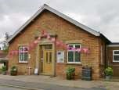
OPEN DAY
It was good to see the many villagers who came along to take a look at the improvements that have been made to the village hall. For those who couldn’t make it here are photos of the hall and the kitchen. The toilets have also been refurbished.
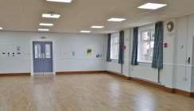

PRIVATE HIRE We are now equipped with wi-fi which should be beneficial for certain hirers. We have kept the cost the same for the remainder of this financial year so, until the end of March 2022 the costs (including full use of the hall and kitchen) will be:
 £8 per hour
 £28 for 4 hours
 £50 for a full day

To book the hall for parties, meetings etc contact me on 219500 or lyndennis456@gmail.com.
Lyn

Middleton on the wolds ce ve school
Executive Headteacher: Mrs E Harros
Station Road, Middleton on the Wolds, Driffield YO25 9UQ
E-mail:middleton.primary@eastriding.gov.uk Tel: 01377 217323
Clothing Collection
If you are having a clear out during the summer, please remember that our next ‘Bag2school’ clothing collection will be on Thursday 23rd September. Any unwanted clothes, shoes, handbags, hats, scarves, jewellery, belts or cuddly toys can go in the collection. The heavier the collection, the more money that is raised for school, so please save all unwanted items for us. Bags must be in the school car park by 9am on Thursday 23rd September.
Middleton Minis– starting back on Tuesday 7th September
Our parent, carer, baby and toddler group runs from 1:30 to 3:30pm every Tuesday afternoon (term time only) at Middleton on the Wolds primary school. Drop in for 20 minutes or the full 2 hours. We look forward to seeing you.

On-going Collections
We collect used stamps and used batteries. Thank you

Middleton on the Wolds Nursery
At Middleton on the Wolds CE (VC) Primary School
 | Providing education for 2, 3 and 4 year olds Monday - Friday.
 | We accept the Government’s childcare vouchers for up to 30 hours of free provision for 3 year olds (conditions apply)
 | Additional sessions can be purchased for £13.50 per session for 3 year olds and £15.75 for 2 year olds.
 | Lunchtime sessions are £1.75 (free if children attend for the whole day) with the option to purchase a school meal for £2.40.
 | Children are welcome in the term after their 3rd birthday for funded places.
For further details, please contact: Sharon Stone
Email: middleton.primary@eastriding.gov.uk Tel: 01377 217323

School Dates
School reopens at 08:40 am on Tuesday 7th September.

A NOTE FROM YOUR VICAR

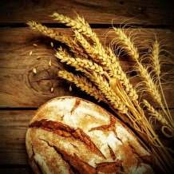
Lammas Tide
The 1st of August is Lammas Day. The word ‘Lammas’ first appears in the writings of King Alfred and is thought to derive from an English word for
‘loaf’ (‘Hlaef’ in Saxon) followed by the word ‘mass’.
When wheat was harvested by hand the farmers would watch the weather anxiously (much as they still do today) for if it rained heavily before the harvest
was gathered in or if it was too dry at the wrong time the crop would be ruined and winter could be a hungry – even deathly time.
So, the farmers would cut the very first ripe wheat, grind it into flour and then bake a loaf which was taken to the local church to be blessed and used for communion (Mass) on the 1st of August. The Lammas service was a way of saying ‘thank you’ for that which was already ripened and also an opportunity to pray for the safe harvesting of the rest of the crops.
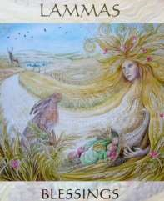
In Medieval times there was much feasting and celebration at this time and bakers would produce special, intricate bread structures shaped into castles, models of Eve in the Garden of Eden, Suns, Moons and stars all brightly coloured with the use of petals, thistles and marigolds.
Over time this festival has been marked less and less by the church, however, many pagan and Wicca groups have information on the internet about the celebration of Lammas – seeing it as an opportunity to give thanks for and to honour creation.
We are so fortunate to be surrounded by the beauty of these Yorkshire Wolds
– we live in a rural landscape where we witness, right outside our front doors, the changing seasons and the agricultural year. It would be most appropriate for our churches to once again mark this special day and use it as an opportunity not only to offer thanks to God but also to give thanks for those who farm the land and provide our food year in, and year out. Jane
‘Blessed are you, Lord God of all creation;
You bring forth bread from the fields
And give us the fruit of the earth in their seasons…’
(from ‘Times and Seasons’ - C of E service for Lammastide)
Jane
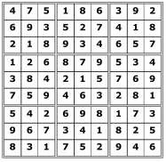
1

90

2

Luke

3

Sharks

4

40

5

France

6

Hudson

7

Bishop

8

Atacama

9

Mamma Mia

10

Italy

Wordwheel:

Gardening

Advertisement
WOLDS WAVES EXCITING NEWS!

Wolds Waves are very excited to announce that we have a new stylist starting on the 19th of July.

Sarah is bringing with her a wealth of knowledge to the salon, Sarah is Toni and Guy trained and has lots of experience in all aspects of hairdressing and specialises in wedding hair.

Sarah has just moved to the village and is super excited to meet you all.

Sarah's hours will be
Monday to Friday 9:30am till 2:30pm
To book an appointment please call the salon on 01377 217379

Could I also take this opportunity to thank each and every one of you for all your loyal and continuous support, I am and always will be thankful to each of you.

Take care Hugs Emma and Sarah.
Advertising Feature

Advertisements
Advertisement
Advertising Feature
Regular group activities

Weekly Groups
Monday Pilates | 6.00-7.00pm Village Hall
Tuesday YCA | 2.00-2.40pm Zoom
Wednesday Line Dancing | 7.30-9.00pm Village Hall
Thursday Middleton Movers  August | 2.00-3.30pm Village Hall
1 Litter Picking Wombles | 10.00am Lime View
2 Parish Council | 7.00pm Reading Rooms
3 Village Hall Committee | 7.00pm Village Hall
13 Book Group | 10.30am North Dalton

LOCAL CONTACTS Bell Ringing Chris Atkin |  | 217285
Book Group/Middleton Movers | Lyn Dennis | 219500
Bowls Club | Rob Bradley | 217435
Country Women’s Association | Christine Johnson | 217374
First Responders | Chris Brent | 219469
Line Dancing | Pat Pottage | 217516
Methodist Chapel | Jane Gray | 07870 562455
Middleton Messenger | Mike Kelly | 07713 620912
 | Lyn Dennis | 219500
 | Tina Walker | 217242
Middleton Womblers | Andrew Naylor | 219072
Parish Clerk | Sandra Morrison | 01262 470496
Pilates | Ian Stephenson | 07973 755717
Reading Rooms | Kath Bentley | 217456
Recreation Club | Dave Newlove | 07901 833784
St Andrew’s Church | Rev Jane Anderson | 219471
St Andrew’s Church Warden | Roger Lowe | 217656
Table Tennis | Louise Newlove | 217801
Village Hall | Lyn Dennis | 219500
Village History | Geoff Wisher | 217517

